**Electric Vehicles Market Size Analysis from 1997 to 2024**

In this raw data, from 1999 to 2024, different types of EVs have been registered with different ranges in most states of the US.We are going to analyze the data of Electric vehicles market from 1997 to 2024,we will also focus on the other states trends and compare them.This analysis is to leverage historical EV registration data to understand the current market penetration of EVs, predict future market growth, and identify key trends and factors driving market expansion.

**Data collection methodology** The data set has many data points such as VIN (1-10),County,City,State,Postal Code,Model Year,Make,Model,Electric Vehicle Type,Clean Alternative Fuel Vehicle (CAFV) Eligibility,Electric Range,Base MSRP,Legislative District,DOL Vehicle ID,Vehicle Location,Electric Utility,2020 Census Tract

**Statistical and Analytic Issues** There are is null value in the data set columns named County, City, Postal Code, Legislative District,Vehicle Location,Electric Utility,2020 Census Tract as it consist of the blank cells in the data sets for which data has not been provided.So we have omitted that row. Blank cells shows the data that were not available

**Data description of the data set of column**

**Data Discription**

VIN (1-10): This column consist of partial vehicle identification number.

County In this column the county in which the vehicle is registered.

City This column consist of where the vehicle is register.

State The state in which the vehicle is registered. It appears that this

dataset may be focused on Washington (WA) state.

Postal code This column consist of where the vehicle is registered.

Model Year The year of the vehicle model.

Make The manufacturer of the vehicle.

Model The model of the veicle.

Electric Vehicle- The type of electric vehicle, eg.(BEV & CAFV)

Type

Clean Alternative Fuel- This column represent a eligibility status for clean alternative

Vehicle (CAFV) Eligibility Fuel programs.

Electric Range The range of the vehicle on a single charge (in miles)

Base MSRP The Manufacturer’s Suggested Retail Price

Legislative District The legislative district where the vehicle is registered.

DOL Vehicle ID Department of Licensing Vehicle Identification.

Vehicle Location Geographic coordinates of the vehicle location.

Electric Utility The electric utility service provider for the vehicle’s location.

2020 Census Tract The census tract for the vehicle’s location.

**Table 1.1: Data description**

**DATA VISUALIZATION AND ANALYSIS**

We will be analyzing the data with the help of some questions. Below is the figure of the data sheet in excel that will give you the hint that how the data is available to us.

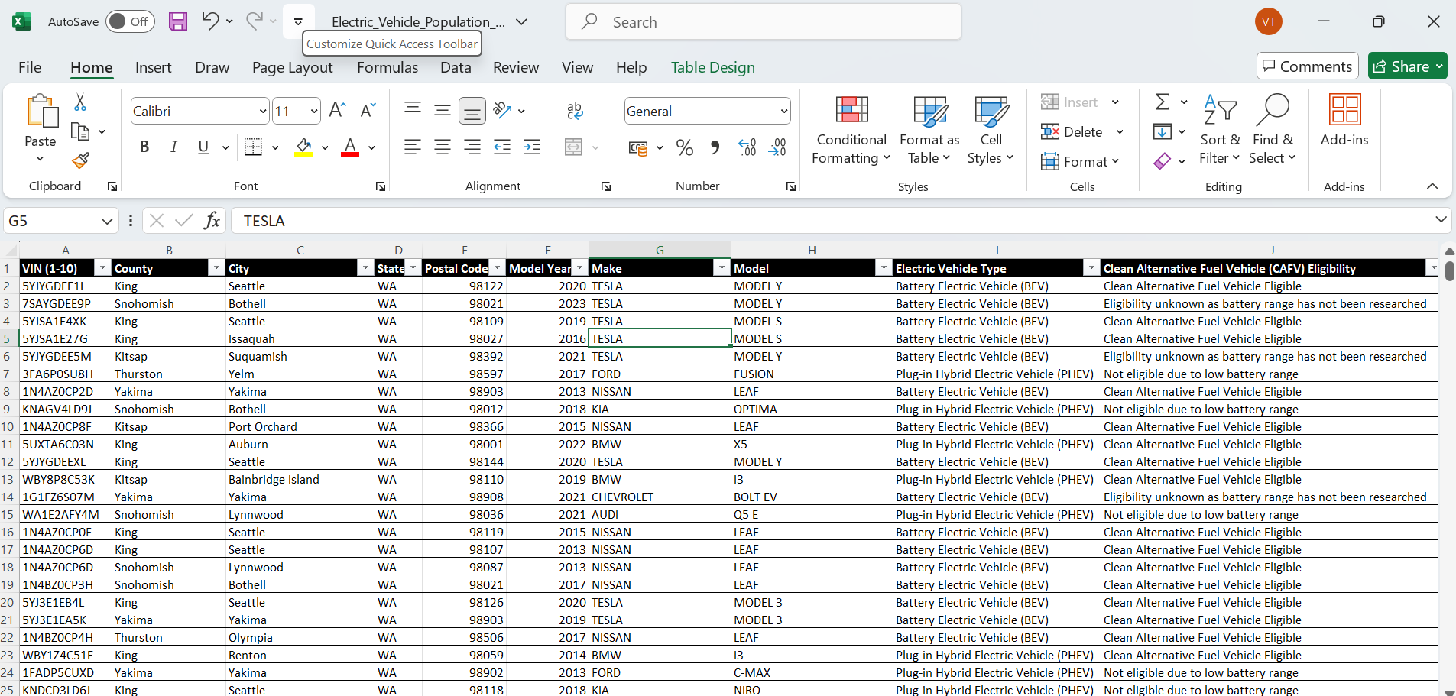

**Figure 2.1: Electric Vehicles Registered Data set**

**Analysis will be easier by giving explanation to the following set of questions.**

1. Analyze the growth of the EV population by model year from 1997 to 2024 ? Which was the year where maximum EV registered from these years?

**Solution:** The explanation of each and every line is provided inside the program itself, Aline beginning with hash tag is the explanation of that particular line of code.

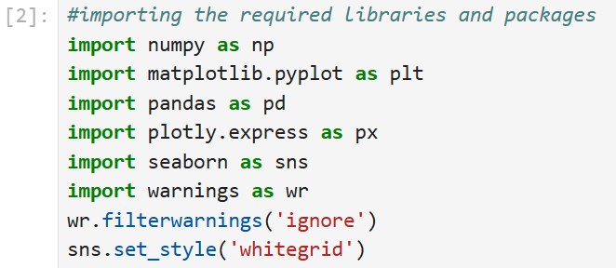

**Figure 2.2: Importing the required libraries and package**

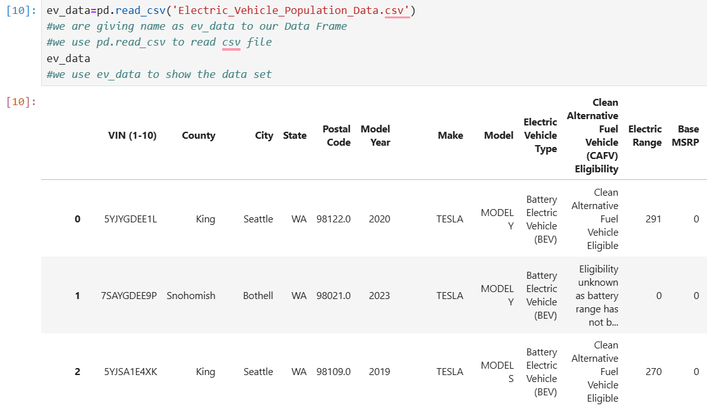

**Figure 2.3: Reading the csv file and show the data set**

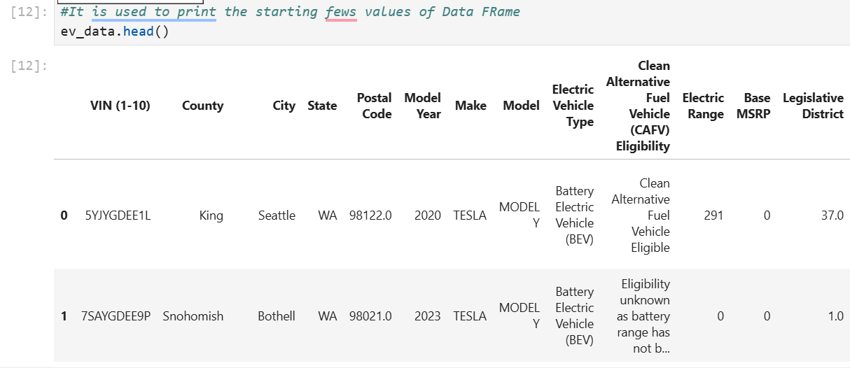

**Figure 2.4: Use of head function**

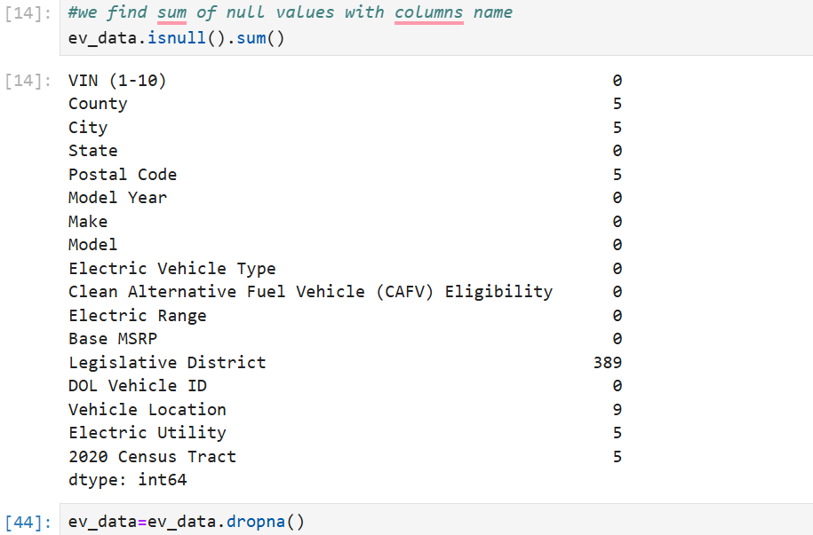

**Figure 2.5: Use of null.sum and dropna function**

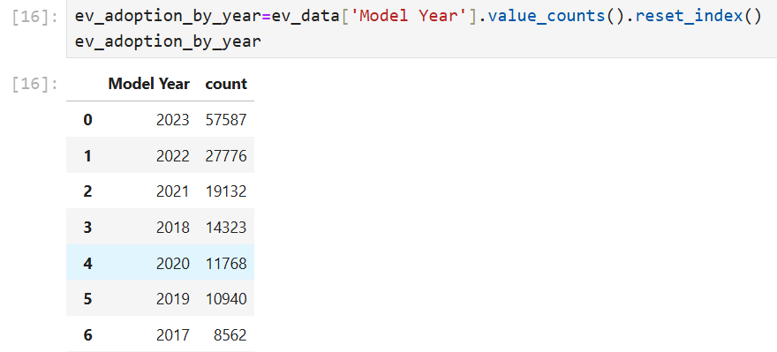

**Figure 2.6: Use of value_counts() method**

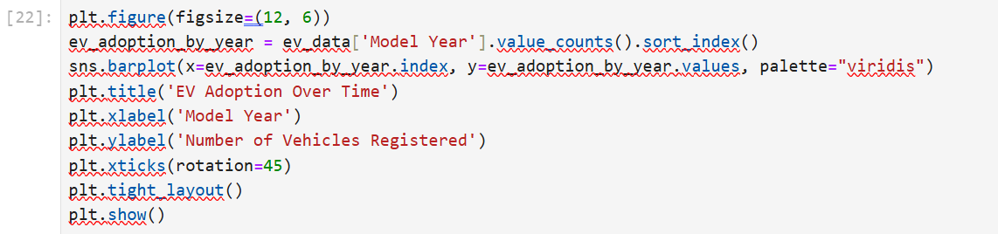

**Figure 2.7: Plotting the Graph**

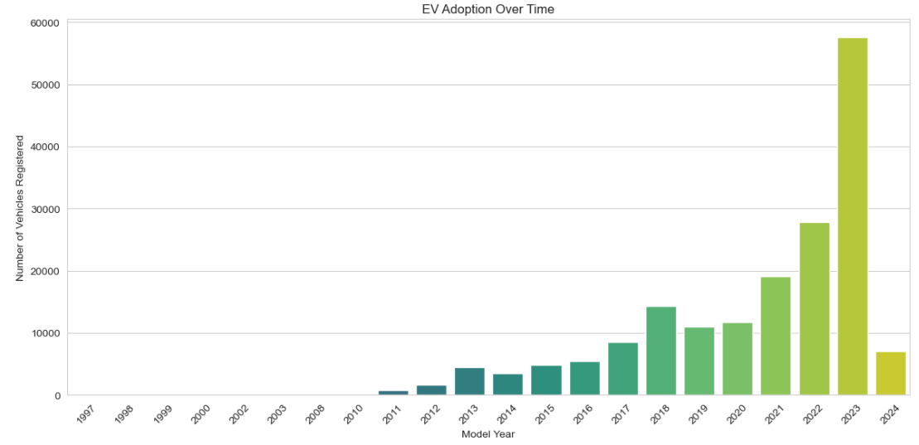

**Figure 2.8:EV adoption by Model Year**

**Conclusion-** From the above bar chart, it’s clear that EV adoption has been increasing over time, especially noting a significant upward trend starting around 2016. The number of registered vehicles grows modestly up until then and rises more rapidly from 2017 onwards. The year 2023 shows a particularly sharp increase in registered EVs, with the bar for 2023 being the highest on the graph, indicating a peak in EV adoption.

1. Geographical Distribution where EVs are most registered (e.g., by county or city)?

**Solution**: Explanation of the code is provided inside the program itself after each line of code.

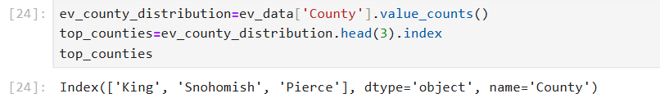

**Figure 2.9:Top 3 counties according to distribution of EVs**

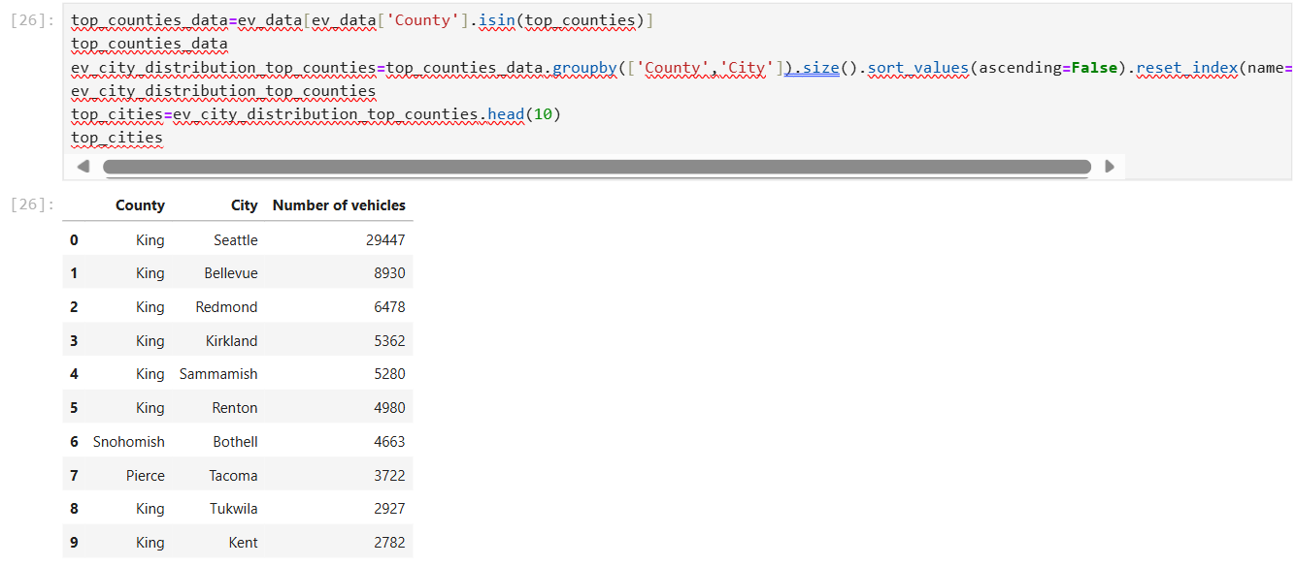

**Figure 2.10: use of isin,groupby,size and sort function**

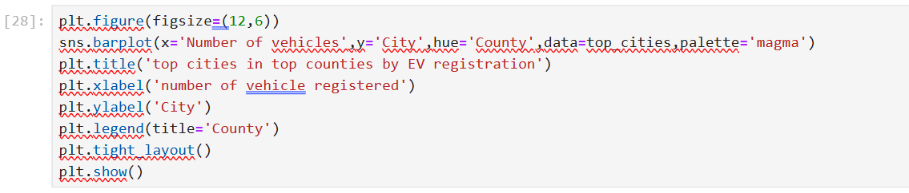

**Figure 2.11:Plotting the bar graph**

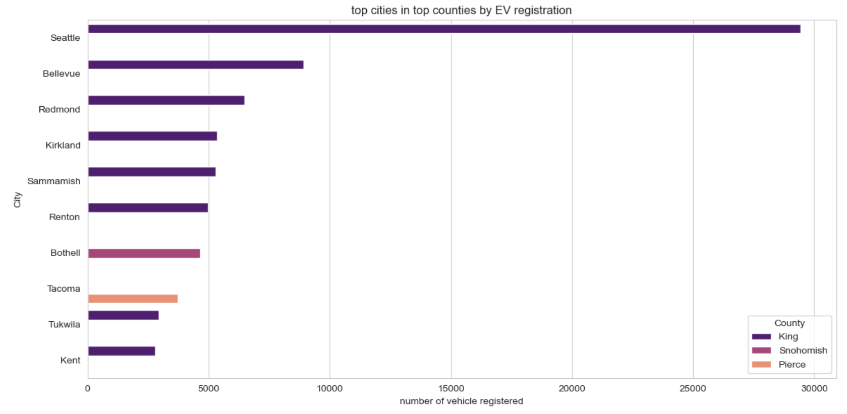

**Figure 2.12: Top cities in top counties by number of EV registered**

**Conclusion-** The above graph compares the number of electric vehicles registered in various cities within three counties: King, Snohomish, and Pierce. The horizontal bars represent cities; their length corresponds to the number of vehicles registered, color-coded by county. Key findings from the above graph?

* Seattle, which is in King County, has the highest number of EV registrations by a significant margin, far outpacing the other cities listed.
* Bellevue and Redmond, also in King County, follow Seattle with the subsequent highest registrations, though these are considerably less than Seattle’s.
* in Snohomish County, such as Kirkland and Sammamish, show moderate EV registrations.
* Tacoma and Tukwila, representing Pierce County, have the fewest EV registrations among the cities listed, with Tacoma slightly ahead of Tukwila.
* Most cities shown are from King County, which seems to dominate EV registrations among the three counties.
* Overall, the graph indicates that EV adoption is not uniform across the cities and is more concentrated in certain areas, particularly in King County.

1. Which is the highest registered EV type from 1997 to 2024?

**Solution:** Explanation of the code is provided inside the program itself after each line of code.

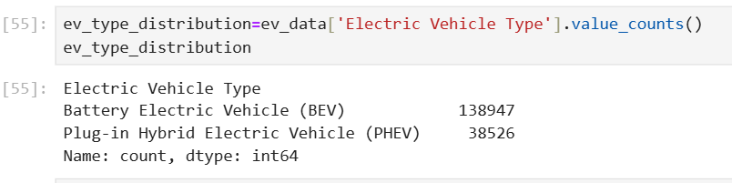

**Figure 2.13: Use of value_counts method for electric vehicle type**

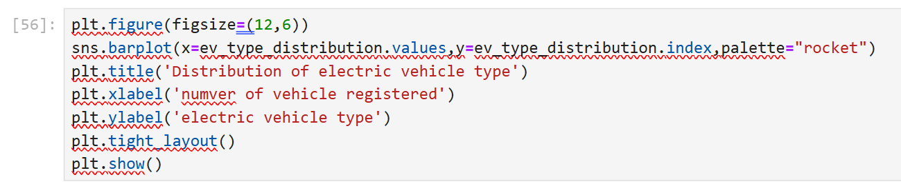

**Figure 2.14: plotting the bar graph**

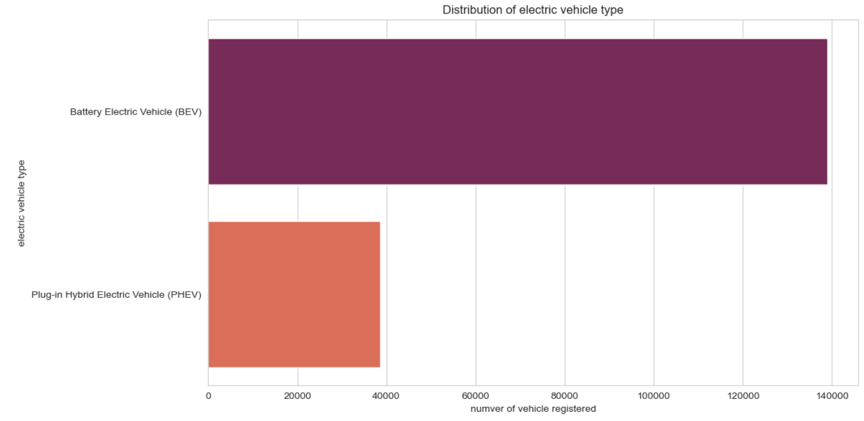

**Figure 2.15: Distribution of EVs types**

**Conclusion-** The above graph shows that BEVs are more popular or preferred over PHEVs among the electric vehicles registered in the United States.

1. Which is the most popular manufacturers for Evs ?

**Solution:** Explanation of the code is provided inside the program itself after each line of code.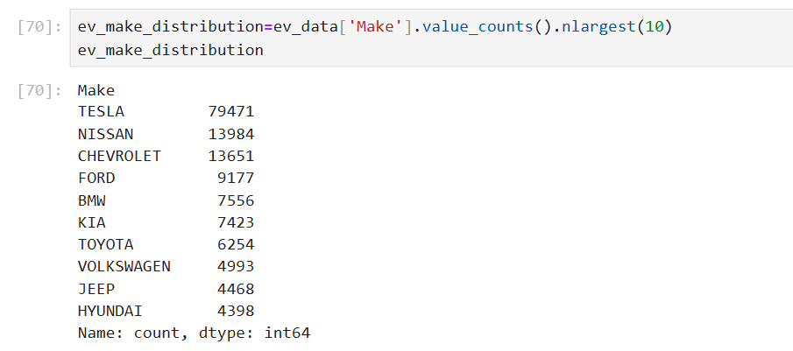

**Figure 2.16: Use value_counts and nlargest for top 10 manufacturers**

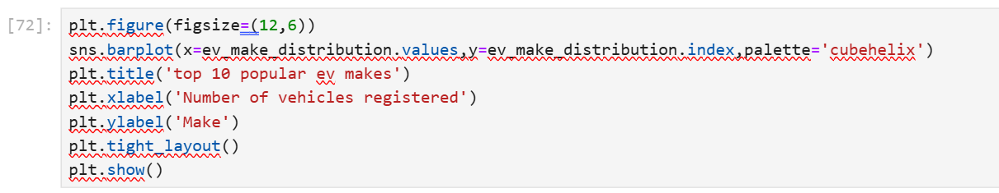**Figure 2.17: Plotting the bar graph**

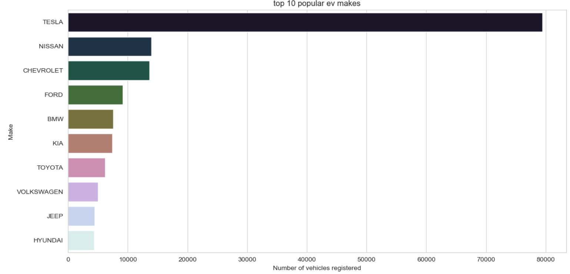**Figure 2.18: Top 10 popular EVs manufacturers**

**Conclusion-** The above chart shows that:

* TESLA leads by a substantial margin with the most registered vehicles.
* NISSAN is the second most popular manufacturer, followed by CHEVROLET, though both have significantly fewer registrations than TESLA.
* FORD, BMW, KIA, TOYOTA, VOLKSWAGEN, JEEP, and HYUNDAI follow in decreasing order of the number of registered vehicles.

1. Among these top producers, which model is the most popular, for a more detailed understanding of consumer preferences at the model level?

**Solution:** Explanation of the code is provided inside the program itself after each line of code.

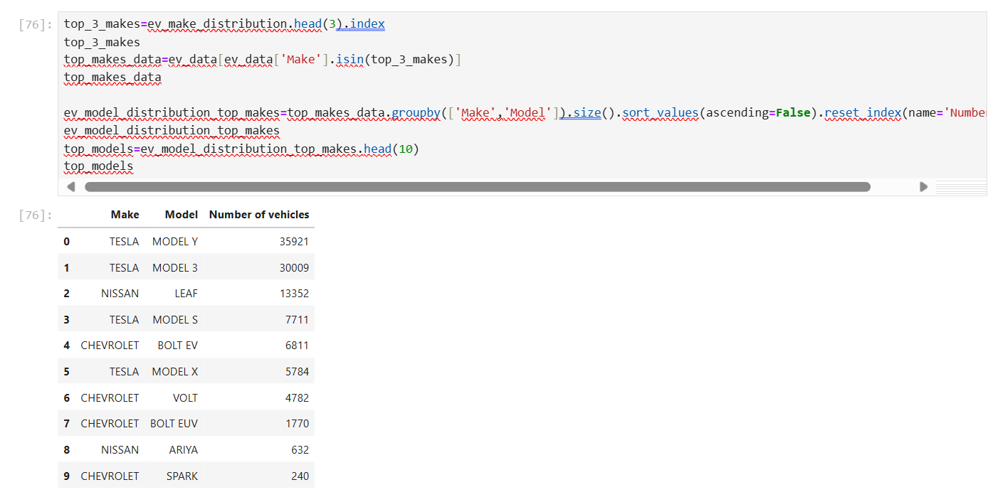

**Figure 2.19: Use the code of isin,groupby,size,sort_values method in above code**

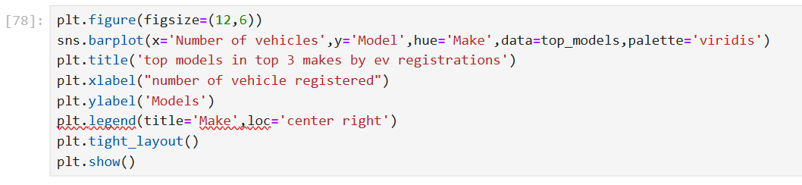**Figure 2.20: Plot the bar graph**